PROJECT DOCUMENTATION

**LESSONS LEARNED LOG**

| **Project:** | **E-Commerce Website for SKANDA**  **by Sarasi Samarasinghe.** |
| --- | --- |
| Release: | April 2022 |
| Date: | 24th March 2021 |
|  |  |
| **PRINCE2** |  |
|  |  |
| Author: | Adithya Narasinghe |
| Owner: | Dr. Yasas Jayaweera (Project Executive) |
| Client: | SKANDA by Sarasi Samarasundara. |
| Document Ref: | LessonsLearnedLog_SKANDA |
| Version No: | 1.0 |

# 1 Lessons Learned Log History

## 1.1 Document Location

This document is only valid on the day it was printed.

The source of the document will be found on the project's PC in location

## 1.2 Revision History

**Date of this revision:**

**Date of Next revision:**

| **Revision date** | **Previous revision date** | **Summary of Changes** | **Changes marked** |
| --- | --- | --- | --- |
|  |  | First issue |  |

## 1.3 Approvals

This document requires the following approvals.

Signed approval forms are filed in the Management section of the project files.

| **Name** | **Signature** | **Title** | **Date of Issue** | **Version** |
| --- | --- | --- | --- | --- |
| Dr Yasas Jayaweera |  | Project Board | 24/03/2022 | 1.0 |
| Adithya Narasinghe |  | Project Manager | 24/03/2022 | 1.0 |
| Mrs. Sarasi Samarasundara |  | Client | 24/03/2022 | 1.0 |

## 1.4 Distribution

This document has been distributed to:

| **Name** | **Title** | **Date of Issue** | **Version** |
| --- | --- | --- | --- |
| Adithya Narasinghe | Project Manager | 24/03/2022 | 1.0 |
| M. Sonali Silva | Start-up Manager | 24/03/2022 | 1.0 |
| J. M. Pasindu Lawantha Bandara | Quality Manager | 24/03/2022 | 1.0 |
| Madapathage Don Kanishka Gimhan | Risk Manager | 24/03/2022 | 1.0 |
| S. K. Helani Sihara Jayawardena | Scheduling Manager | 24/03/2022 | 1.0 |

# 2 Table of Contents

**1 Lessons Learned Log History** **2**

1.1 Document Location 2

1.2 Revision History 2

1.3 Approvals 2

1.4 Distribution 2

**2 Table of Contents** **3**

**Lessons Learned Log** **4**

3 Purpose 4

4 Management/Quality Process Assessment 4

5 Deviations 5

6 Method/Tool Performance 5

7 Recommendations 6

8 Measurements of Effort 7

9 Quality/Test Assessment 7

**Table of figures**

Figure 1:Measurements of Effort 07

# Lessons Learned Log

## 3 Purpose

This lesson learned document focuses on the lessons the team has learned during the project that will be useful in future projects. The document contains the management framework used, techniques, and methodologies. This document also consists of all the challenges that were faced by each team member as well. This document contains the level of effectiveness or ineffectiveness of the quality and test assessments.

## 4 Management/Quality Process Assessment

The project manager and the quality manager, respectively, were in charge of project management and quality. A few essential management and quality-control aspects are listed below.

* Initially, the project manager analyzed each team member's capabilities and allocated roles accordingly.
* Then the startup manager was able to get a complete understanding of the client's needs and get the project's fundamental criteria.
* The team successfully set and reached the deadlines and built the website accordingly.
* GitHub and Google Drive have been used to control versions of all documents to allow team members to work on the latest version of the reports and keep the project board updated on the project progress.

* The system's testing was successfully completed by the quality manager.

* The Risk Manager has been assessed all the risks and provided a mitigation plan in order to continue the project without any hassle.
* To meet the project's goals, team members completed all allocated duties, regardless of their assigned roles.
* The team members arranged frequent meetings with the client and the project board to update on the project progress. Each week, new features introduced to the system and how they function were presented to them for confirmation.
* The project team met with the project supervisor weekly, and the supervisor's feedback helped the team improve critical aspects, including time management, artefact development, and documentation.

* To handle project tasks, the project team used the ASANA project management tool. Apart from that, a WhatsApp group was created for members to interact.

Team members used online technologies such as Skype and Zoom to conduct group meetings due to the COVID-19 pandemic. The team had to deal with connectivity issues throughout those meetings.

## 5 Deviations

Due to the prevailing global pandemic (COVID-19), we cannot have face-to-face meetings frequently with our clients. Therefore, we used online platforms for some client meetings, which provided less comprehension than face-to-face discussions.

## 6 Method/Tool Performance

From the starting point to the final release, the team members used the PRINCE2 project management method to complete the project. All the required documents were prepared using the PRINCE2 documentation templates provided in BREO.

The software tools that the project team used are:

* **Draw.IO**

Draw.IO is an open source web based modelling tool that supports creating UML diagrams for the system and software. The Draw.IO used to create UML diagrams for the project.

* **Figma**

The initial designing of the system interfaces was done by using Figma.

* **WordPress**

WordPress is a website framework used by more than 40% of the top 10 million websites around the world and is known for its ease of use, security, and scalability.

* **WooCommerce**

WooCommerce is the De facto e-commerce technology used with WordPress, which is used by more than 3 million websites and accounts for close to 30% of the top 1 million e-commerce sites around the world.

* **Selenium**Selenium is a UI testing framework used to run automated tests on a browser. This is used to conduct the quality testing.
* **GitHub**A repository hosting service used for the purpose of version controlling the documents.
* **Microsoft Office Package**Used for the purpose of documentation.
* **Google Docs**Used for the purpose of documentation.

## 7 Recommendations

* Understanding each team member's skill level in relevant areas is essential to increasing project productivity.
* After knowing their skills to work on each role, assigning members to the project roles such as project manager, startup manager, scheduling manager, quality manager, and risk manager should be chosen.
* In project management, using management tools like Trello may be quite beneficial.
* Appropriate communication technologies (Zoom meeting, WhatsApp group call) among the project team members allow for efficient and successful communication.

## 8 Measurements of Effort

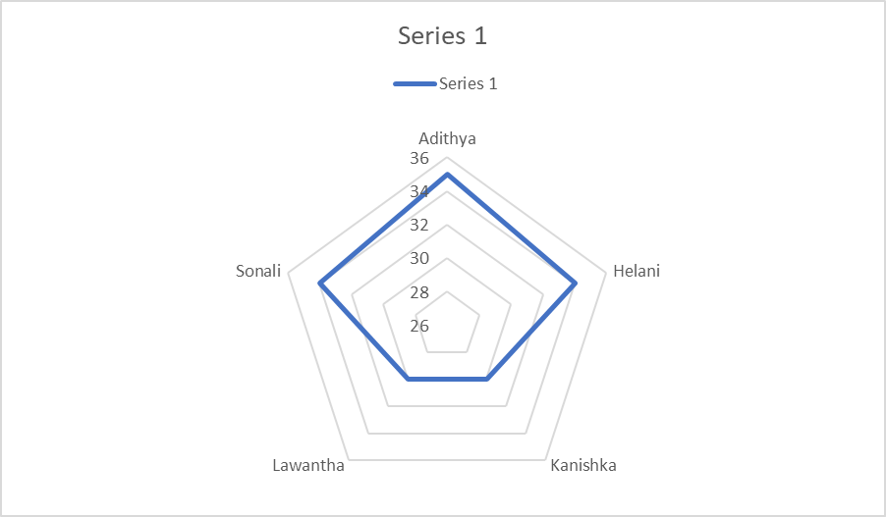

**Figure 1:Measurements of Effort**

Figure 1 indicates the efforts of the team members and how many hours they have spent on the project. Hours per week are shown in the blue line, and the time is calculated by analysing group members' completed tasks each week.

## 9 Quality/Test Assessment

The discovery and investigation phases of the software development process are focused on testing. The testing step verifies that the system satisfies the requirements of the consumers. The outcomes of the testing phase will assist in the reduction of errors within the project. The following items were included in the review stage:

* Planning
* Entry checking
* Documenting
* Review meeting
* Examining
* Defect fixing

The quality review is a systematic evaluation that assists developers in removing problems early in the development process. In some cases, the quality reviewer may discover a few flaws throughout the review process, such as,

* Incorrect interface specification.
* Deviation from standards.

During the quality review process, incorrect interface requirements might lead to interface misuse from module to module, risking the project. Standard displacement occurs when a proper review is not performed and provided, causing the project to deviate from the required standard.

Since the project adheres to the Prince2 process, all units generated during the implementation phase merged into the final system following testing. It allows software developers to be subjected to continuous testing to detect mistakes.